Project Design Phase-II
Data Flow Diagram & User Stories
Date | 02 NOVEMBER 2025
Team ID | NM2025TMID01366
Project Name | Laptop Request Catalog Item
Maximum Mark | 4 Marks

Data Flow Diagram
A Data Flow Diagram (DFD) visually represents how data flows through the “Laptop Request Catalog Item” system. It shows how the user request is captured, processed, approved, and fulfilled.
This system enables employees to request laptops easily through the Service Catalog, routes the request for manager approval, and updates the request status dynamically.

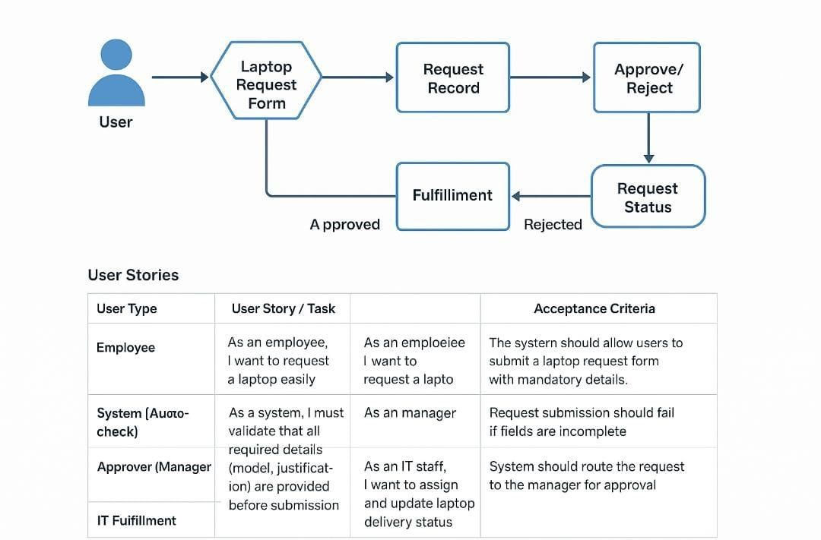

User Type | Functional  Requirement  (Epic) | User  Story  Number | User Story / Task | Acceptance  Criteria | Priority | Release
Employee | Laptop  Request  Submission | USN-1 | As an employee, I want to request a laptop easily from the catalog so I can start my work quickly. | The system should allow users to submit a laptop request form with mandatory details. | High | Sprint-1
System (Autocheck) | Request  Validation | USN-2 | As a system, I  must validate  that all required details (model, justification) are provided before submission. | Request submission  should fail if fields are incomplete. | High | Sprint-1
Approver  (Manager) | Approval  Process | USN-3 | As a manager, I want to review and approve/reject laptop requests from employees. | System should route the request to the manager for approval. | Medium | Sprint-2
IT  Fulfillment | Asset  Assignment | USN-4 | As an IT staff, I want to assign and update laptop delivery status. | The request status must change to “Completed” once delivered. | Medium | Sprint-2

